## Nesting Components & Inputs

An application in Angular is a set of custom components glued together in HTML via inputs and outputs.

So far we’ve only built applications with a single component, our goal now is to start building applications that are *composed* of multiple components working together.

Breaking up an application into multiple logical components makes it easier to:

* Architect an application as it grows in complexity.
* Re-use common components in multiple places.

The goal of this lecture is to break up our small application into 3 components and start *gluing* them together.

**Learning Outcomes**

* How to create and configure multiple components in one application.
* How to enable Input Property Binding on a custom component so components can communicate with each other.

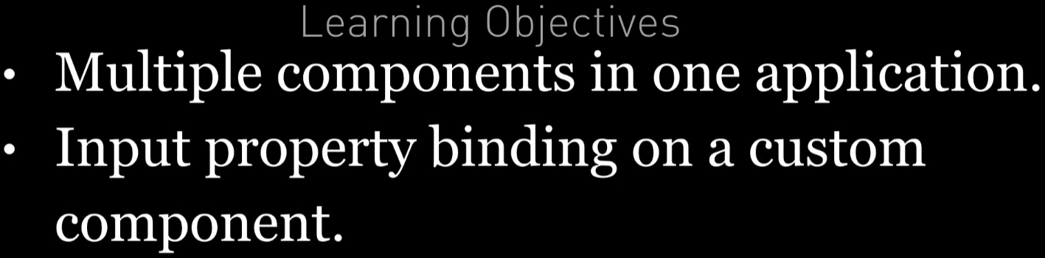

**Create & Configure Multiple Components**

If you think of a typical webpage we can normally break it down into a set of logical components each with its own view, for example most webpages can be broken up into a header, footer and perhaps a sidebar.

We are going to break up our application into a root AppComponent, this component won’t have any functionality and will just contain other components.

This component will hold our JokeListComponent and our JokeListComponent will hold a list of JokeComponents.

  Most Angular apps will have a root component called *AppRoot* or *AppComponent*, this typically just acts as a container to hold other components.

Our components will therefore nest something like the below image:

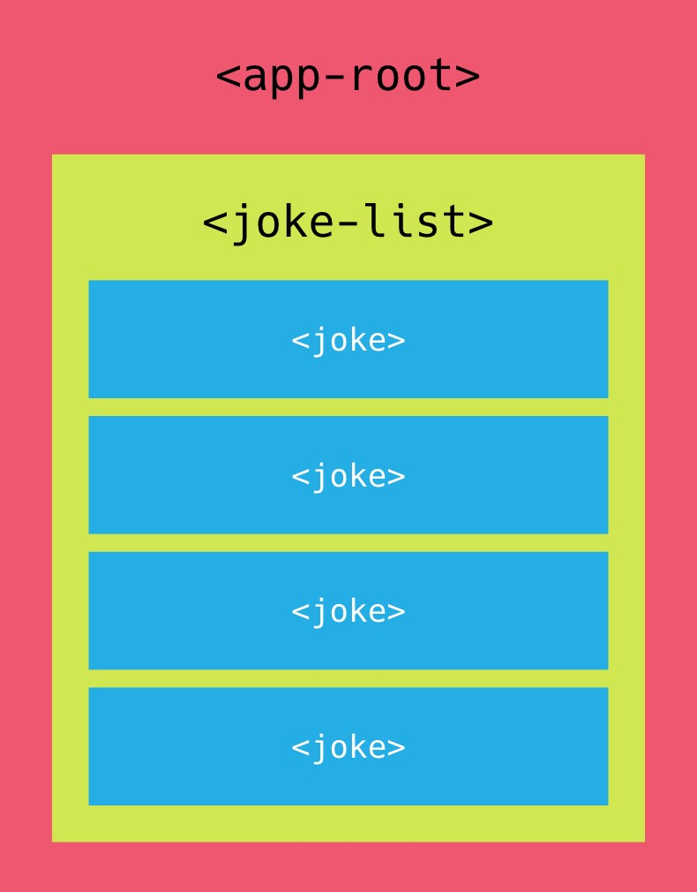



For the

*convenience*

of learning we are going to keep everything in one file. When

building Angular apps the recommended approach is to have one component per

file.

### JokeComponent

This is going to show/renders an single/individual Joke. This looks similar to our previous module JokeListComponent we just removed the NgFor since this component will now render a single joke and removed constructor also as we don’t require it here.

@Component({

selector: 'joke',

template: `

<

div class="card card-block"

>

<h4 class="card-title">{{joke.setup}}</h4>

<p class="card-text"

[hidden]="joke.hide">{{joke.punchline}}</p>

<a (click)="joke.toggle()"

class="btn btn-warning">Tell Me

</a>

<

/div

>

`

})

class JokeComponent {

joke: Joke;

}

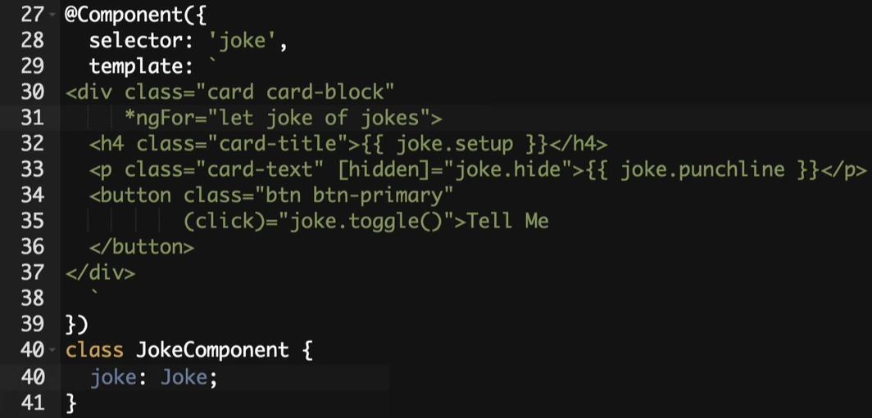

### JokeListComponent

We’ve broken out a joke into its own JokeComponent so now we change the JokeListComponent template to contain multiple JokeComponent components instead.

@Component({

selector: 'joke-list',

template: `

<

joke *ngFor="let j of jokes"></joke

>

`

})

class JokeListComponent {

jokes: Joke[];

constructor() {

this.jokes = [

new Joke("What did the cheese say when it looked in the mirror?", "Hello-me

(

Halloumi)"),

new Joke("What kind of cheese do you use to disguise a small horse?", "Mask-a-

pony (Mascarpone)"),

new Joke("A kid threw a lump of cheddar at me", "I thought

‘

That

’

s not very

mature

’

"),

];

}

}

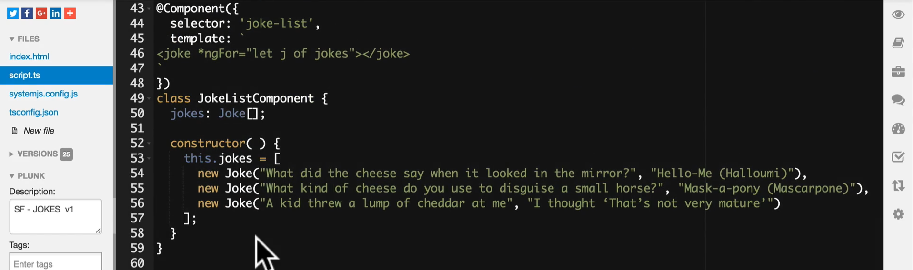

### AppComponent

Our final component is our new top level AppComponent, this just holds an instance of the JokeListComponent.

@Component({

selector: 'app',

template: `

<

joke-list></joke-list

>

`

})

class AppComponent {

}

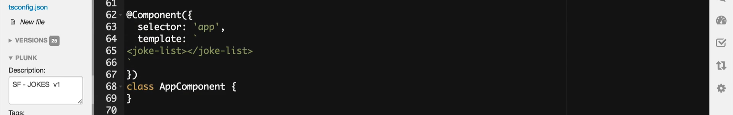

### Configuring multiple Components

In order to use our new components we need to add them to the declarations on our NgModule.

And since we’ve changed our top level component we need to set that in the bootstrap property as well as change our index.html to use the <app></app> root component instead.

@NgModule({

imports: [BrowserModule],

declarations: [

AppComponent,

JokeComponent,

JokeListComponent

],

bootstrap: [AppComponent]

})

export class AppModule {

}

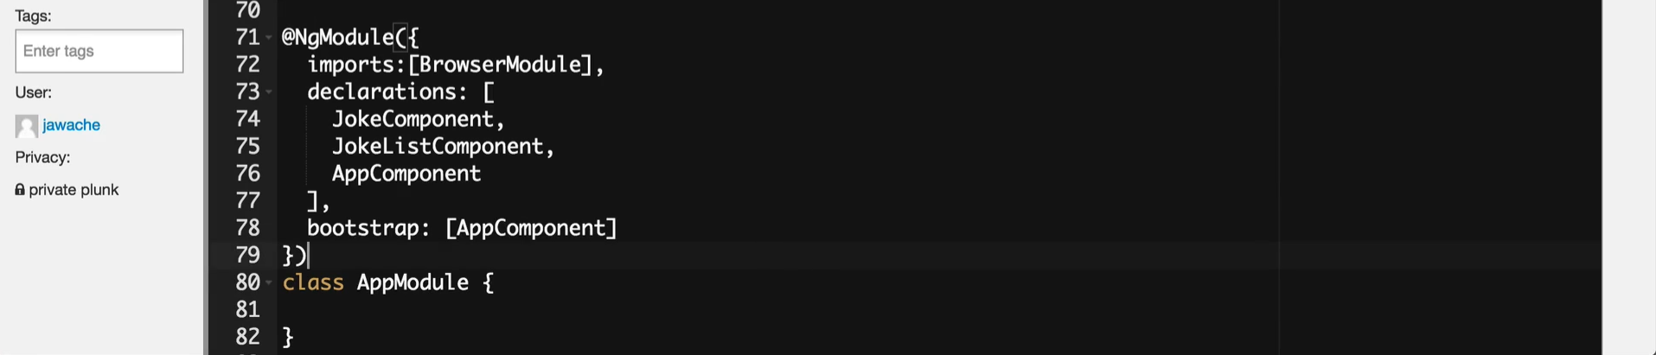

<

body class="container m-t-1"

>

<app></app>

<

/body

>

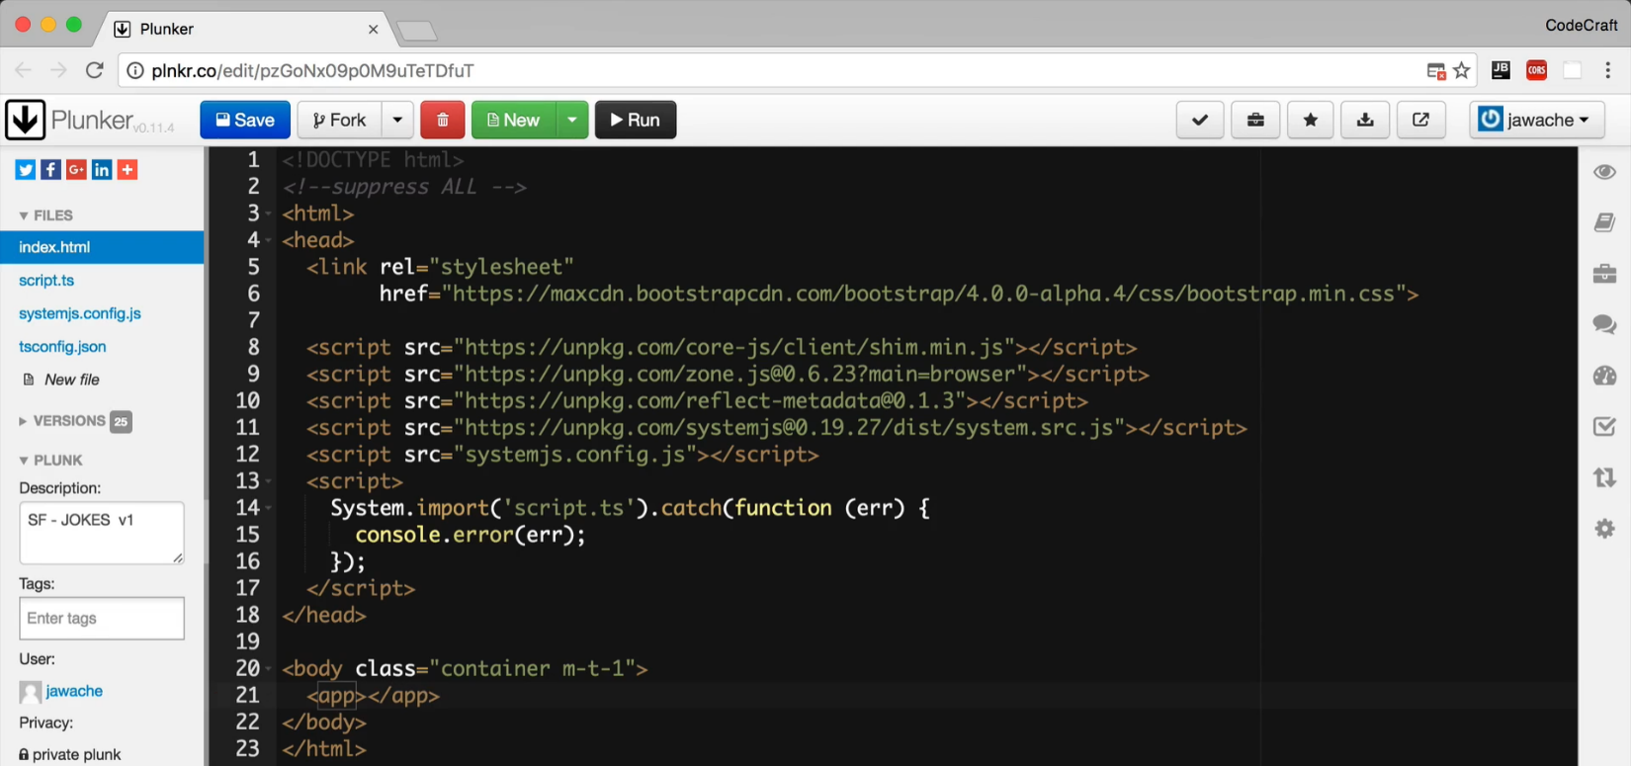

**NOTE:**  In Angular we need to be explicit regarding what components & directives are going to use in our Angular Module by either adding them to the imports or declarations property.

In **Angular 1** each directive when added via a script tag was globally available, which made it convenient for smaller projects but a problem for larger ones. Issues like name clashes came up often as different third party libraries often used the same names.

With **Angular 2** third party libraries can export the same name for components but only the version we explicitly include into our Angular Module will be used.

The built-in directives we are using such as NgFor are all defined in CommonModule

which is again included in BrowserModule which we have already added to our NgModule imports. So this is why NgFor is allowed to use in our HTML.

**Input Property Binding on a Custom Component**

If we ran the application now we would see just some empty boxes with some errors in the console, like so:

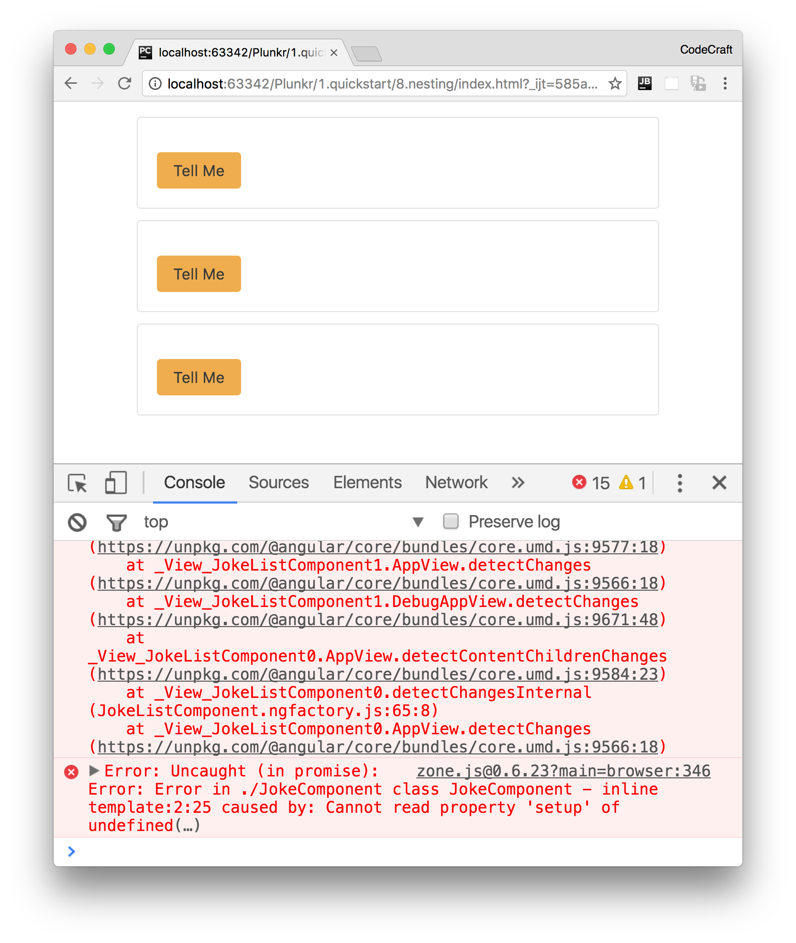

The errors should read something like:

class JokeComponent - inline template:2:25 caused by: Cannot read property 'setup' of undefined

The above should give you a hint about what’s going on

1. It’s something to do with the JokeComponent
2. It’s something to do with the template.
3. It’s something to do with the setup property.

So if we look at the offending part of our JokeComponent template:

<

h4 class="card-title">{{joke.setup}}</h

4>

Essentially Cannot read property 'setup' of undefined in the context of joke.setup means that joke is undefined, it’s blank

If you remember from our JokeComponent class we do have a property called joke:

class JokeComponent {

joke: Joke;

}

And we are looping and creating JokeComponents in our JokeListComponent, like so:

<

joke *ngFor="let j of jokes"></joke

>

But we are not setting the property joke of our JokeComponent to anything, which is why it’s undefined.

Ideally we want to write something like this:

<

joke *ngFor="let j of jokes" [joke]="j"></joke

>

In just the same way as we bound to the hidden property of the p tag in the element above we want to bind to the joke property of our JokeComponent.

Even though our JokeComponent has a joke property we can’t bind to it using the [] syntax, we need to explicitly mark it as an *Input* property on our JokeComponent.

We do this by pre-pending the joke property in the component with a new annotation called @Input, like so:

import { Input } from '@angular/core';

.

.

.

class JokeComponent {

@Input() joke: Joke;

}

This tells Angular that the joke property is an *input* property and therefore in HTML we can bind to it using the [] input property binding syntax.

This @Input now becomes part of the *public interface* of our component and we can use in using input property binding syntax.

Now if you run the application all the functionalities should work fine

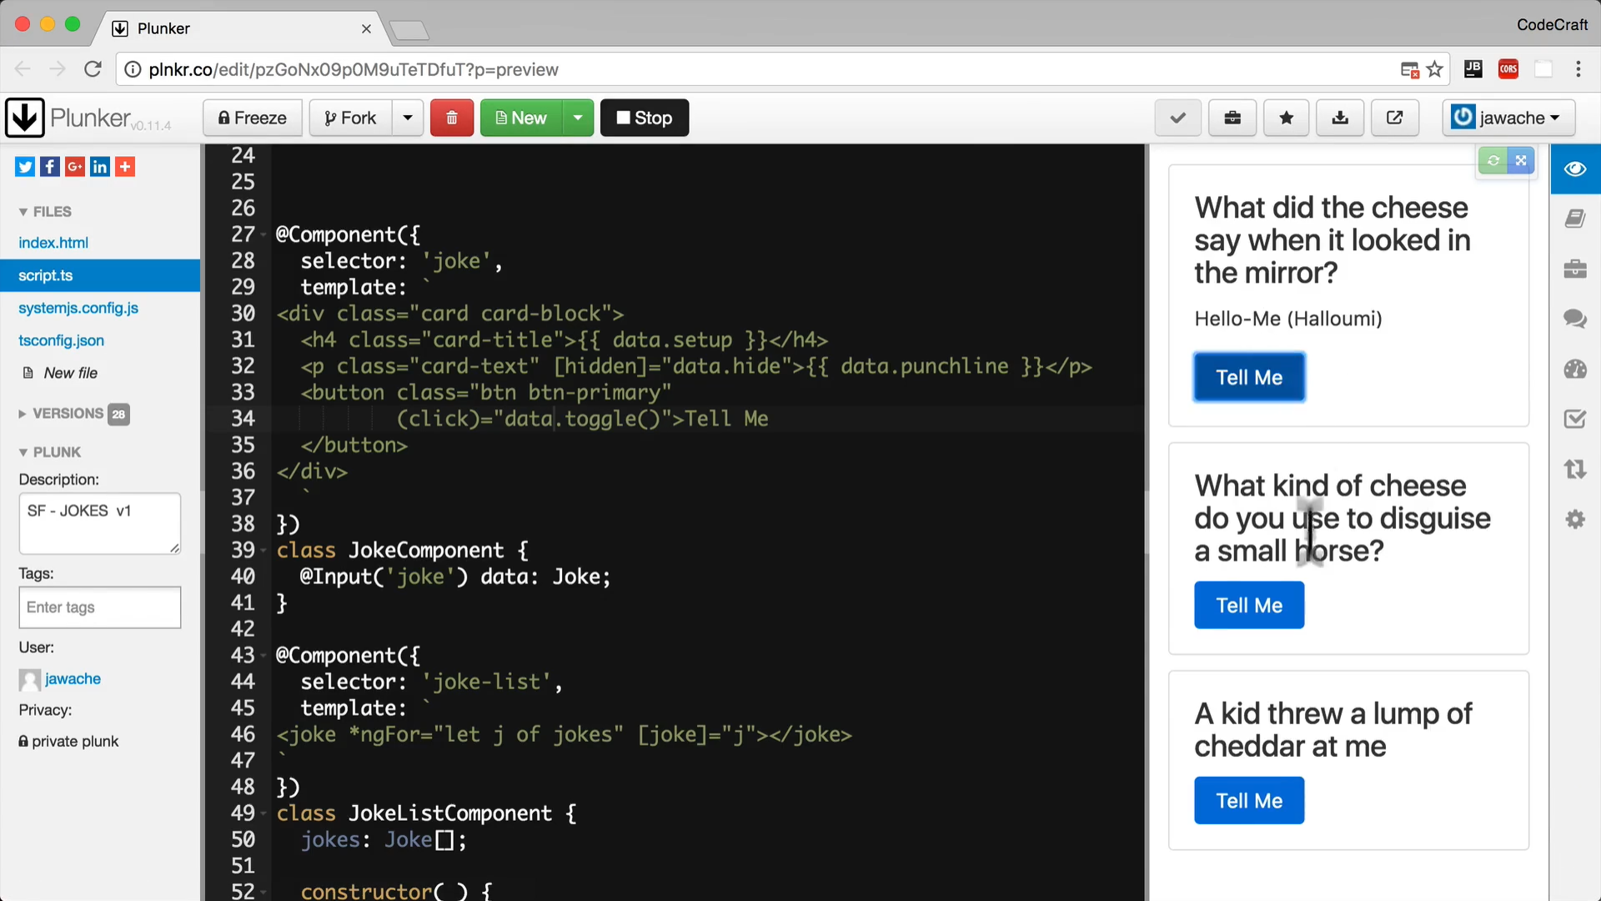

Lets say at some future point we decided to change the joke property of our JokeComponent to perhaps just data, like so:

class JokeComponent {

@Input() data: Joke;

}

Because this input is part of the public interface for our component we would also need to change all the input property bindings every where our component is used, like so:

<

joke *ngFor="let j of jokes" [data]="j"></joke

>

Not a great thing to ask the consumers of your component to have to do.

This is a common problem so to avoid expensive refactors the @Input annotation takes a parameter which is the name of the input property to the outside world, so if we changed our component like so:

class JokeComponent {

@Input('joke') data: Joke;

}

To the outside world the input property name is still joke and we could keep the JokeListComponent template the same as before:

<

joke *ngFor="let j of jokes" [joke]="j"></joke

>

**Summary**

An Angular application should be broken down into small logical components which are glued together in HTML.

Its normal to have one root component called AppComponent which acts as the root node in the component tree.

We need to explicitly declare all components in the applications root NgModule.

We can make properties of our custom components input bindable with the [] syntax by prepending them with the @Input annotation.

**Listing**

<http://plnkr.co/edit/LKj9OAoUMIUZhDS5HAiP?p=preview>

